**Other Calendar Research**

**Outlook**

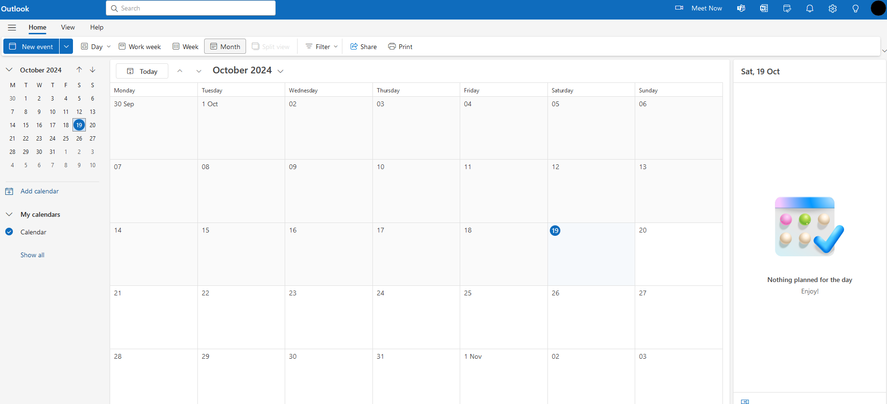Pros

* Clean aesthetic
* Integrates with other Microsoft products, eg. teams etc
* Straight forward layout

Cons

* Desktop app limits amount of events per day one can see in month mode (cuts them off instead of allowing you to zoom out, therefore requiring weekly mode use or swapping between)

**Google Calendar**

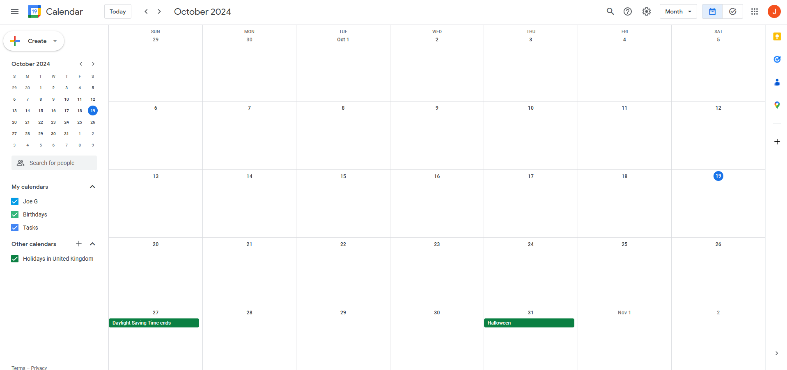Pros

* Clean aesthetic as well
* A lot more customisable than outlook
* Android integration

Cons

* Google so possibility of service being cancelled without warning+

**Apple Calendar**

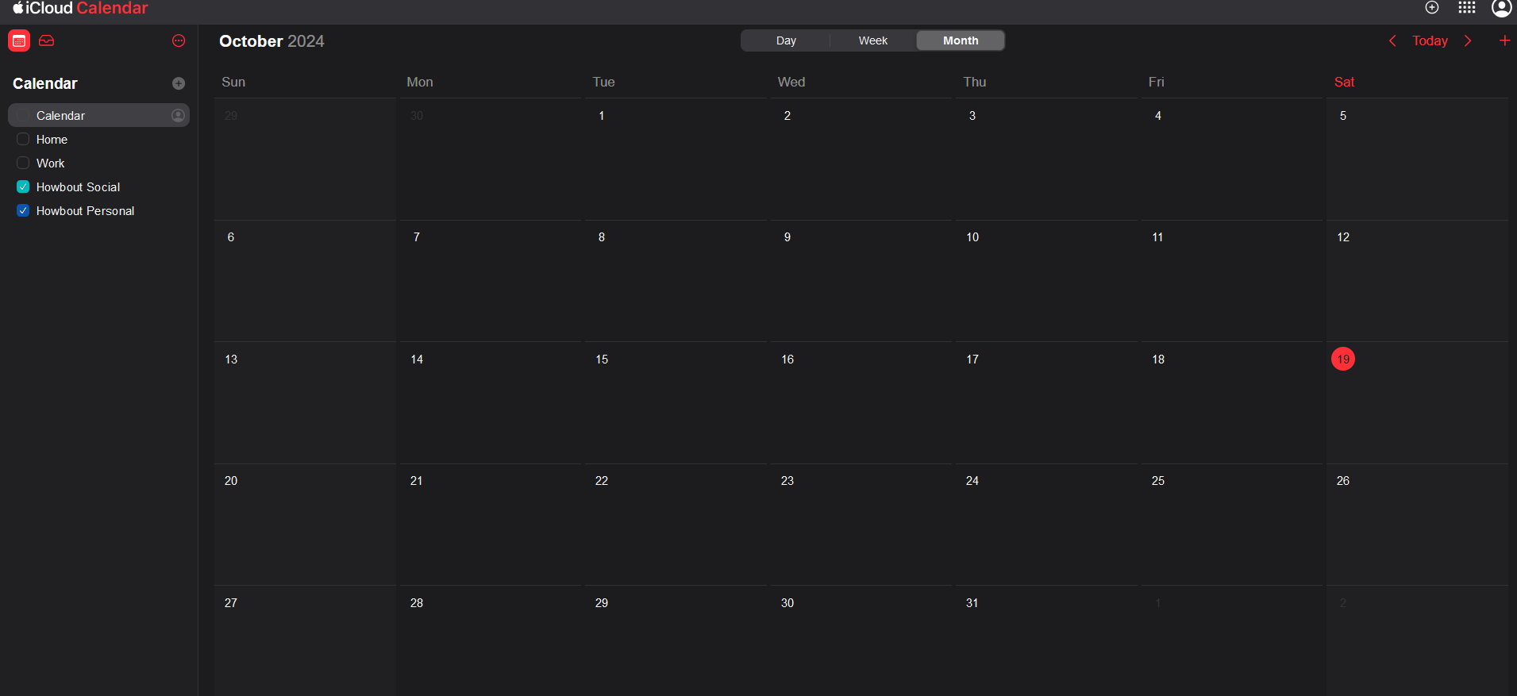Pros

* IOS integration across Apple devices
* Automatic event detection

Cons

* Less customisable
* Automatic event detection can be hit or miss